**San Francisco Bay University**

**EE553 - System on Chip (SoC) Design**

**Homework Assignment #3**

**Due day: 3/9/2022**

**Instruction:**

1. **Push the answer sheet to Github**
2. **Overdue homework submission could not be accepted.**
3. **Takes academic honesty and integrity seriously (Zero Tolerance of Cheating & Plagiarism)**
4. Complete SoC design to blink one LED and shift back and forth among 4 LEDs on Zybo Z7-10 board

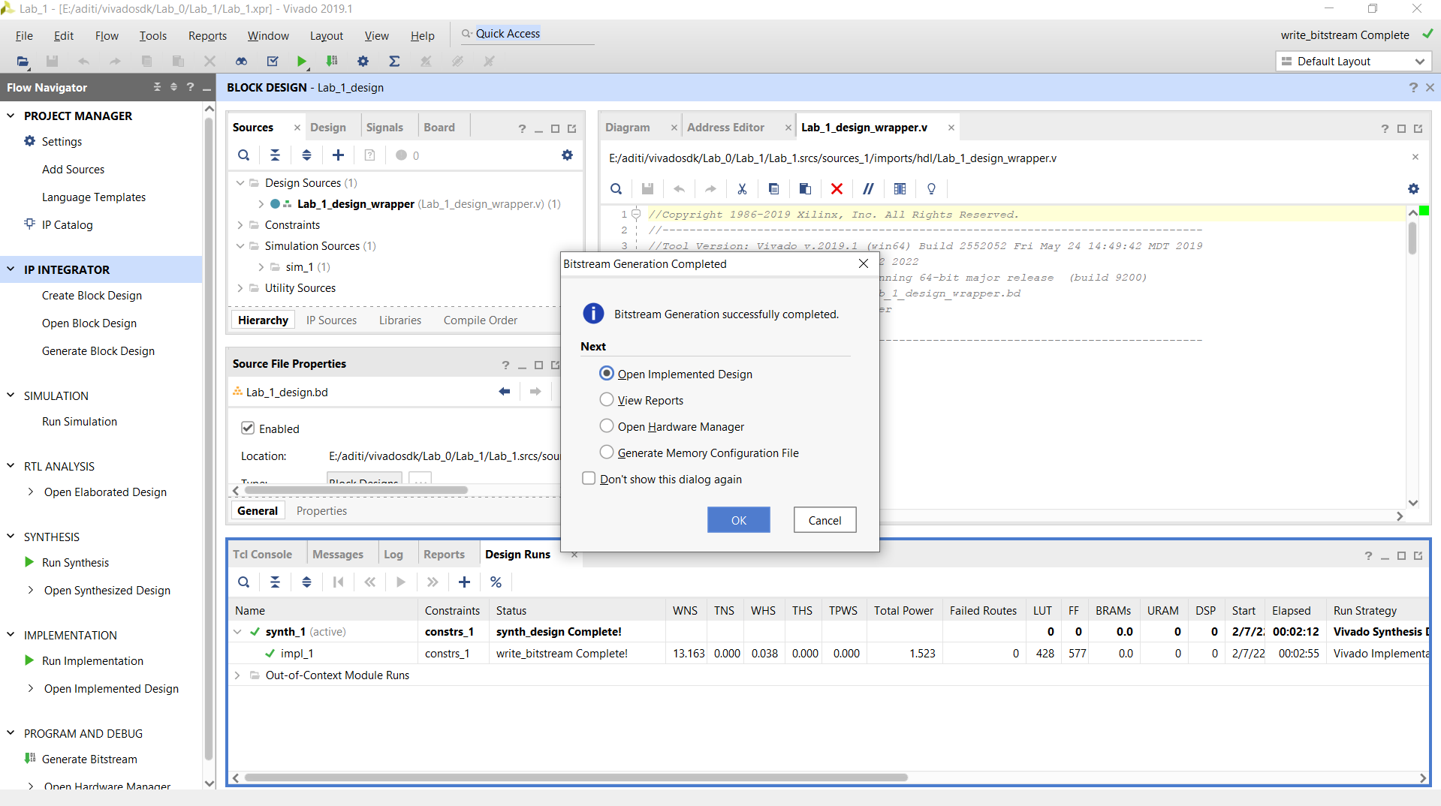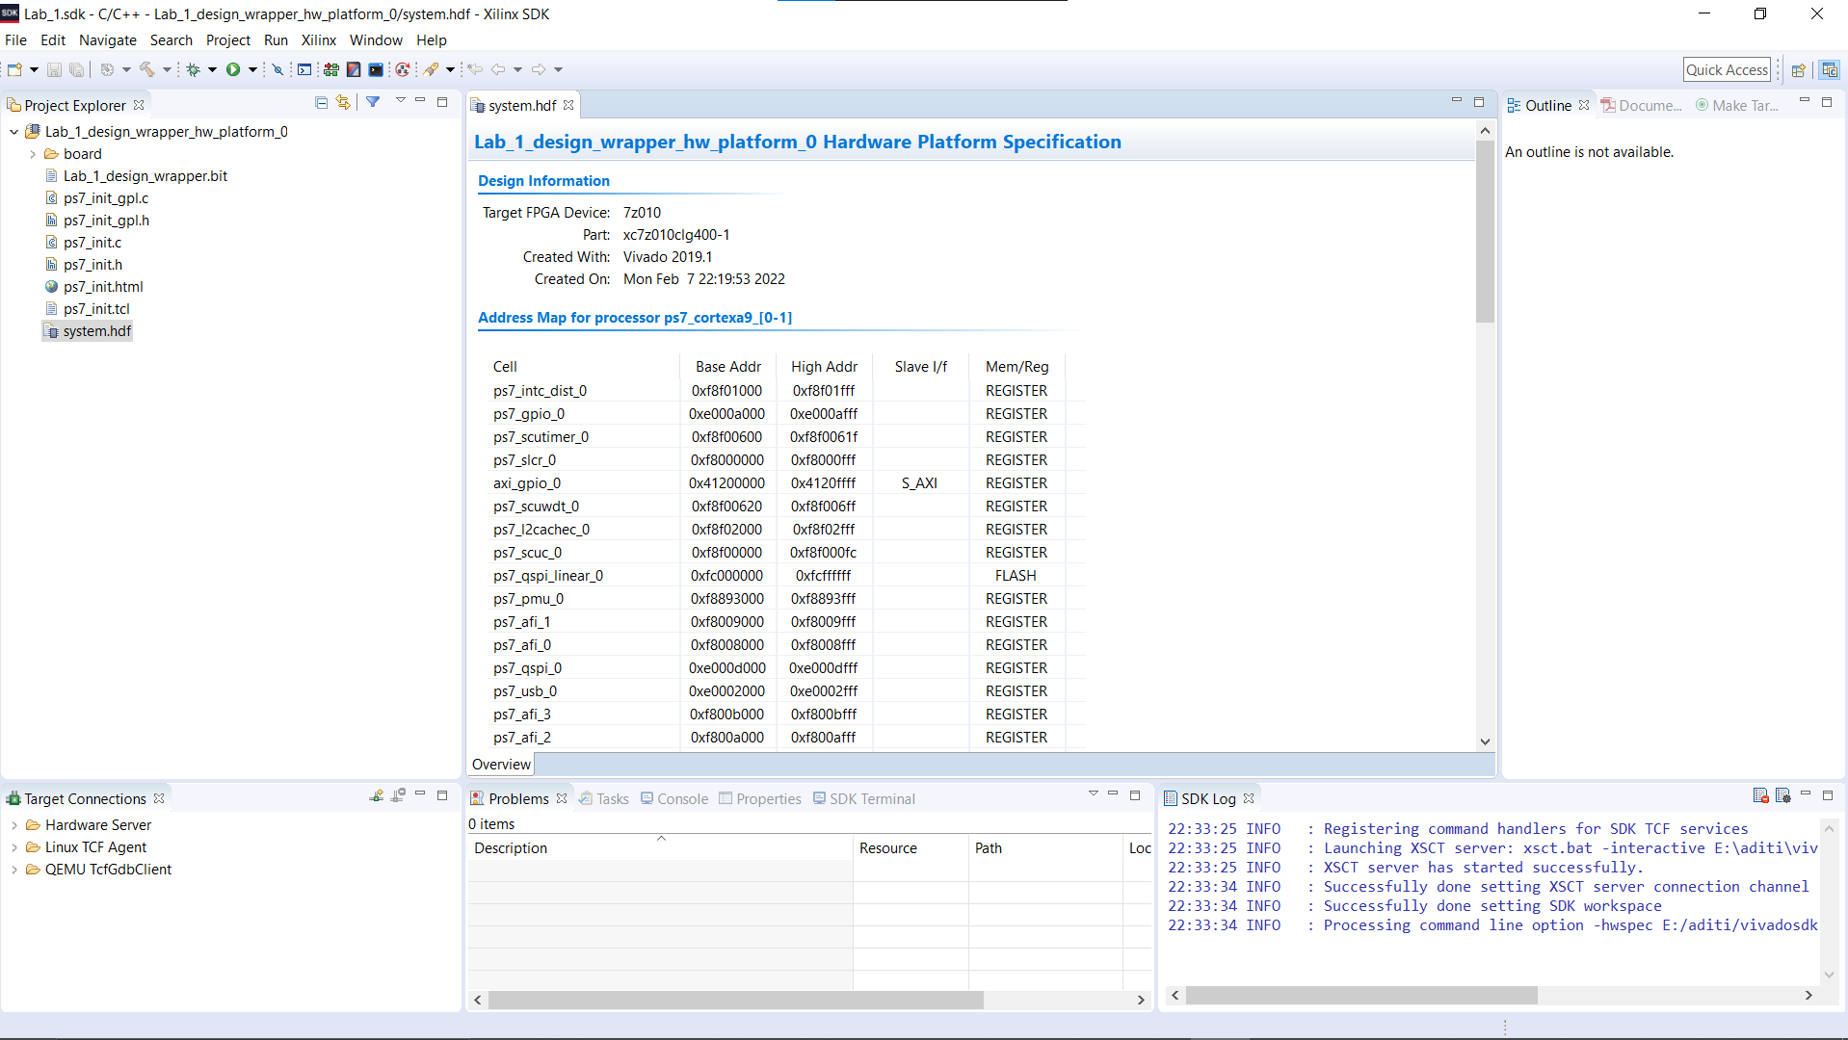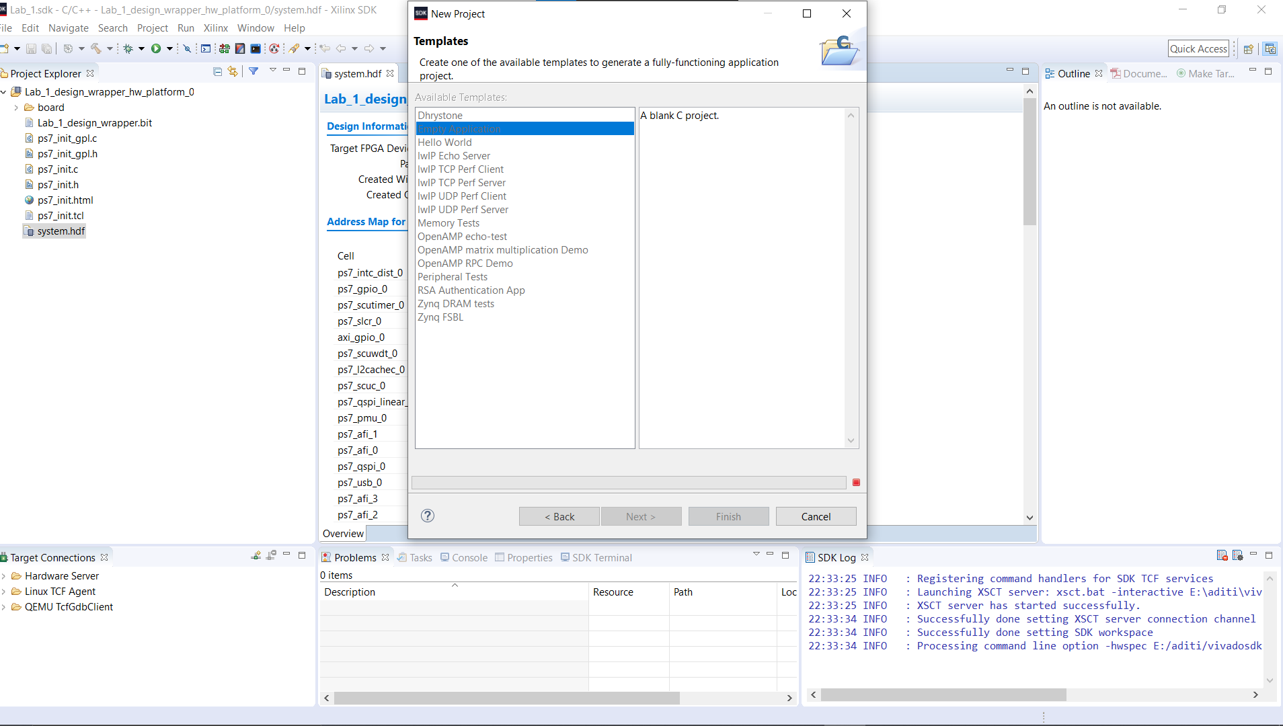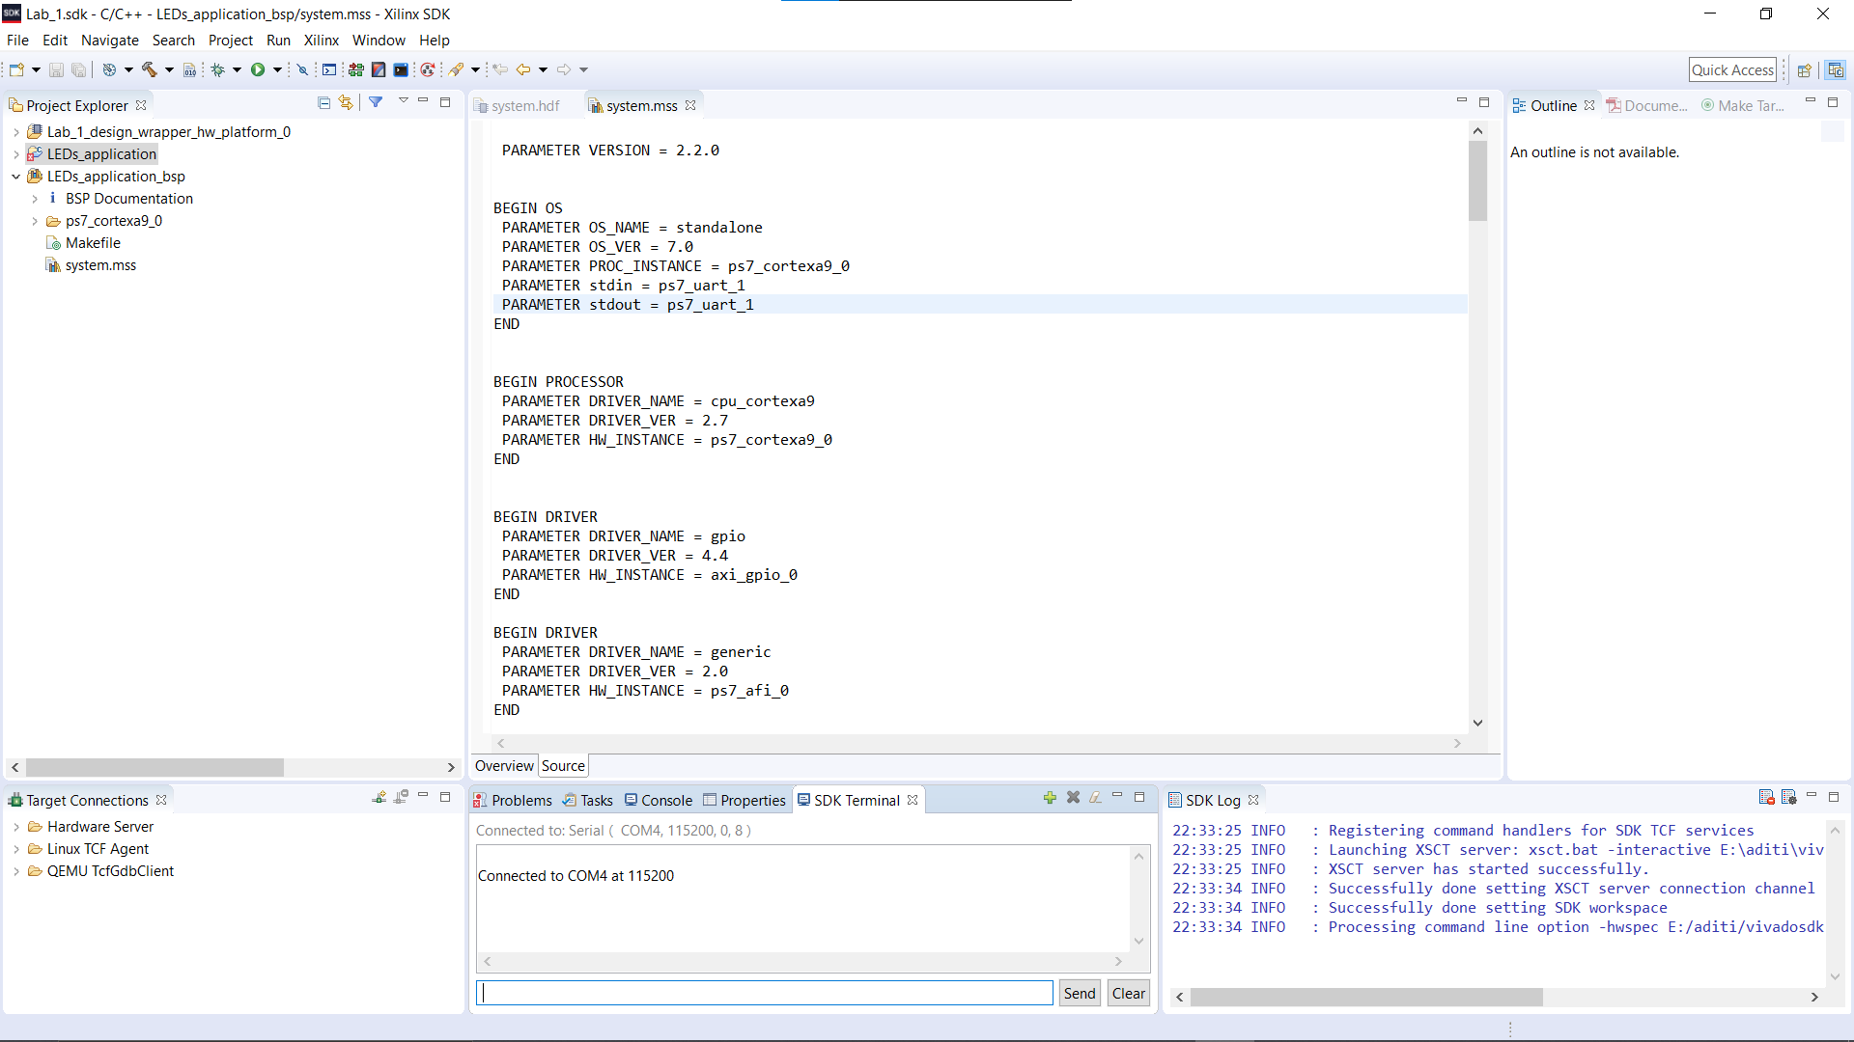

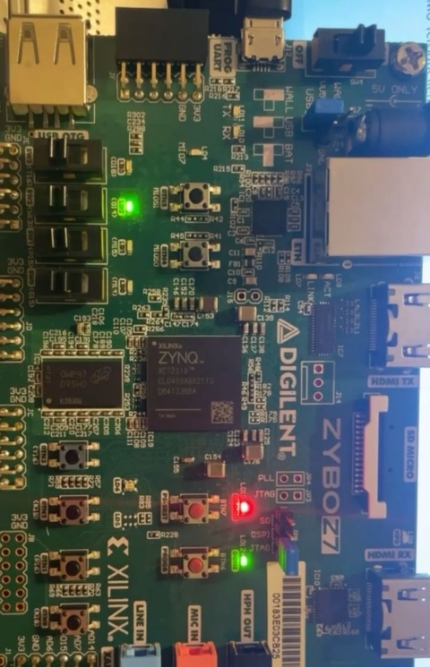 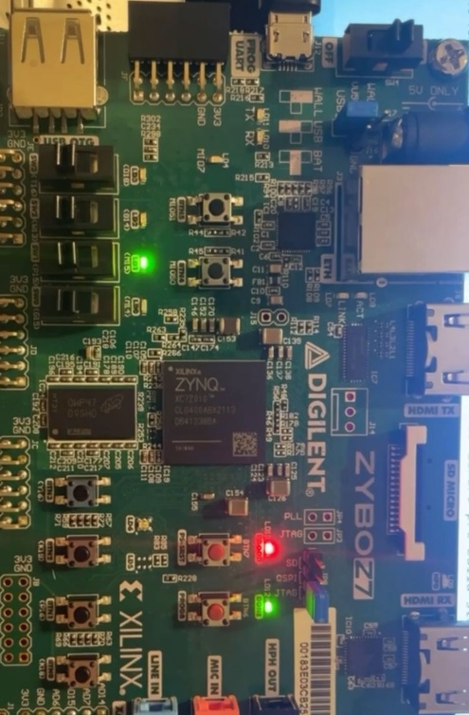 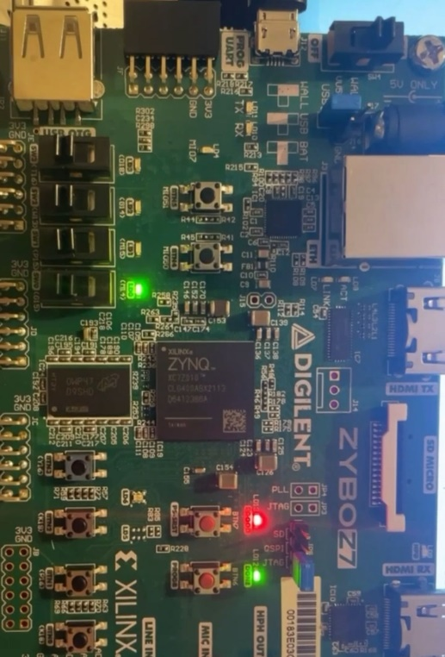

1. Design hardware and software to make 2 LEDs at the two ends of 4 LEDs on the board blinking and move in different directions, and then back and forth

